

**TROY TECH**

**PROJECT PROPOSAL**

***of***

**ROBOT PLAYING FOOTBALL**

Prepared For:

Dr. Mustafa Mert ANKARALI

Electrical and Electronics Engineering Department

METU

**Prepared by:**

Kağan Özaslan

Caner Potur

Hasan Özkara

Mert Kayış

Mustafa Ercan Okatan

Project Start Date: 10.2018

Project End Date: 06.2019

Project Duration: 8 Months

Estimated Cost: 150 USD

TABLE OF CONTENTS  
1. Executive Summary …………………………………………………………  
2. Introduction …………………………………………………………………...   
3. Team Organization…………………………………………………………...   
4. Standards………………………………………………………. …………  
5. Deliverables ……………………………………………………………………..  
6. Approach to Solution…………………………………………………………...  
7. Requirement Analysis……………………………………………………….   
8. Conclusion……………………………………………………………………..  
9. Appendices…………………………………………………………………….  
.

**1. EXECUTIVE SUMMARY**

Many fields in industry started to involve robotic solutions nowadays. Sport industry serves technological products in order to meet the needs of sport activities. For instance, hawk-eye in tennis or goal-line technology in football support these games. In the future, robotic technologies move beyond to support sportsmen and sportswomen. Many people working on robotics think that robots will substitute for humans in many fields and one of the fields will be the sport. Troy Tech serves a football playing robot: HELEN-V.

We consider the communication between the player robot and the controller as the most challenging part of the project. We propose some methods for the communication. Firstly, we plan to transfer video of the game to the controller room so that for the operator it is easy to determine which command should be sent. For the video transfer, we plan to use a FPV module which is a video plotting module working at 5.8 GHz. This frequency will not interrupted by any signals like telephone or wi-fi connection.

**2. INTRODUCTION**

In this proposal report, the objectives, requirements, solution methods, cost analysis, standards related to our new project are introduced. Our company, Troy Tech is interested in creating new approaches in robotic systems and specially tele-operated robots nowadays.

In the “Devices trying to score in each other’s goals” project, we will design and construct a robot that scores in opponent robots goal. The robot will not be self-operated or autonomous, a person will control the movements of the robot instead. By doing the robot easily and accurately controllable by an operator at a distance wirelessly, we will accomplish entertainment purposes of the game. Therefore, we are sure that it will be fun for our clients.

This project has various challenging ways such as the transfer of video data and commands wirelessly upto 30 meters. We will come up with new solutions to these problems in an outcome-oriented manner. These solution approaches will also be efficient in terms of both budget and time. We are aware of the fact that the most important cost is time in engineering. Our progress is planned carefully to meet the schedule of the project.

**3. TEAM ORGANIZATION**

Troy Tech consists of 5 engineers specialized in different areas of engineering. All members are experienced and skillful professionals who understand their responsibilities and are always seeking for better ways to improve the task. Our company’s organizational structure this project are provided in Figure 1 below. It includes professional skills and current roles of team members.

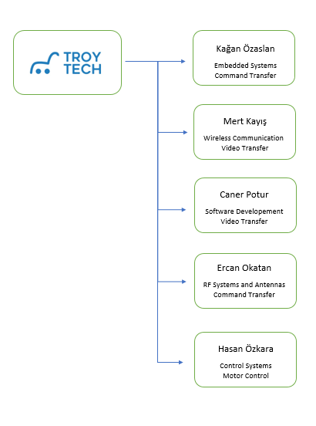

Figure 1: Organizational Chart

*Kağan Özaslan* serves as embedded system engineer. He is experienced from his two internships conducted in two companies.The former one produces electronic lockers, whereas the later one is a software embedded company who is developing advance assistance systems for Audi. He took microcontroller course in last year at METU under computer specialization area.

*Mert Kayış* is responsible for the wireless data transfer of the project and he serves as RF engineer at Troy Tech. He conducted his summer practice in a team that design radar systems and gained some experience on RF systems.

*Caner Potur* has chosen Computer as the specialization area and has experience on coding algorithms and analysing camera systems. Therefore he can contribute to software and video transferring-analysing systems of the company projects.

*Mustafa Ercan Okatan* is responsible for both the mechanical subsystems and the command transfer. His summer practice gained him the experience on RF systems and antennas. He is also interested in mechanical systems since his early ages. Thus, his abilities and interests match with his responsibilities well.

**4. STANDARDS**

Our company aims to design and build a football playing robot. This football game consists of two team (two player robot) and each team tries to score into the opponent’s goal. The player robots are allowed to move freely in its own half-field only. The control of the player must be remote control.

For a fair competition , there should be some standards related to playing field and the game itself. The things that should be standardized are listed below.

* Ball: Size, weight and color of the ball should be determined. We do not prefer a heavy ball since a heavy ball can lead to fail our mechanical system and also it can increase the power consumption. On the other hand, considerably large balls can make it impossible to score. Also, the color might be important for the companies which intended to image process. However, we plan to transfer the video of the game, so the color of the ball will not be a essential issue unless we intend to change our solution. It is enough for us to use a ball whose color is contrast to the color of the floor.
* The play field: Some standards on the play field are essential for a fair game. The walls should be made of the same substance and they should be in the same color. Since we will watch the video of the game, contrast colors for the wall, the floor and the ball are preferable. Thus, we can easily distinguish the walls from the floor and the ball. On the other hand, the goal line and the half line should be a bit thicker in order to control our player accurately. Also , their colors should be easily distinguishable.
* The players: The players’ dimensions should be adjusted according to the size of the goals. Their heights should be adjusted in order to standardize the view angle of the cameras. The colors of the players might be essential if we prefer to use image process. We should determine whether the player will not cross the half-line autonomously or not. Of course, we do not prefer autonomous systems since they increase the cost.
* Distance between the playfield and the controller room: It must be 30 m at least but there should be some standards on the obstacles between the flayfield and the controller room.

**5. DELIVERABLES**

Troy Tech wants their customers to have a lot of fun with Troy Tech products besides serving best quality. That’s why Troy Tech aims for the highest customer satisfaction and keeps working with that motive. The most important deliverable is the robot which is playing football and its remote control. Also video receiver is included.The customer needs an external monitoring device to screen the robot’s eye display. However there will be another pack which includes the screen or a VR glass. In addition, rechargeable battery, its charging adapter and the user manual is included.

The deliverables of main pack is described below.

**5.1 Equipments**

**1. Robot**

The customer will be provided with the robot playing football. This robot is remote controlled. With the camera assembled on the robot and video receiver, it can transmit video to remote screen instantaneously. Also, customer can look at the robot with naked eye and for this case it’s not needed to look at screen indeed.

**2. Remote Control**

The customer will control the robot with this remote control. Remote control makes customer to be able to move the robot in desired direction and also make the shoot to the opposite goal.

**3. Receiver Unit**

This receiver unit is used for receiving the video shared from robot. Troy Tech guarantee that video transmission is correctly processed in the distance at least 30m.

**4. Rechargeable Battery**

The customer will be provided with a rechargeable battery. The battery will be placed on the robot, there is no need to extract it from the robot to charge it.

**5. Battery Charging Adapter**

The customer, will be provided with the charging adapter for the rechargeable battery. According to the country delivered, the customer will be provided with an original adapter plug designed according to the Electrical Distribution Standards of the respective country.

**6. User Manual**

Each information is provided in a user manual with a wide scope with customer requirement. A 5-year warranty is also provided to ensure that products are renewed or renewed under certain conditions (these conditions are covered by the warranty).

**7. VR Glasses or Suitable Screen(Optional)**

If customer doesn’t want to look at robot with naked eye, and desires using from a distance, it’s requires a screen to show the video which is transmitted by robot. Customer may choose this option whether they want to buy or not.

**6. APPROACH TO SOLUTION**

We divided the problem into four main parts, they are video transfer, command transfer, movement/motor drive and shooting. We studied and did research on each of these main parts so that we can find effective and sensible solutions.

**6.1 Video Transfer**

We are planning to use FPV camera module with both transmitter and receiver units so we are able to monitor the playfield. The most important advantage of this method is that we will not employ image processing technique. The most common FPV frequency, used by most drone pilots is 5.8GHz because it is not require too much power and can transmit a high distance and has very good video/audio quality. Moreover, this frequency will not interrupted by any signals like telephone or wi-fi connection.

**6.2 Command Transfer**

We are supposed to send command to robot from far distances. In order to do that, we have two choices. Plan A is using a compact RC controller, and the Plan B is using joystick with an microcontroller such as arduino, and send the movement data provided by customer to the robot. We are going to compare both of them with respect to cost/performance criteria, and real results that we will test. Then we are going to decide on one of them. Here is an example of decoded signal from RC controller receiver.

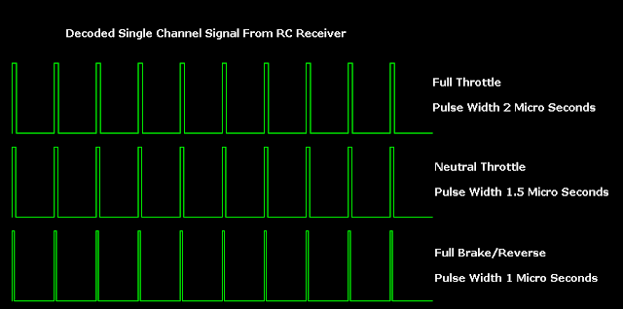

Figure 2: Example Decoded Signal From RC Receiver

**6.3 Movement and Motor Drive**

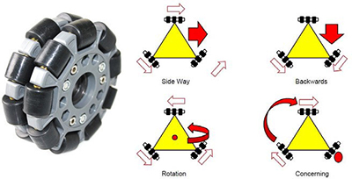

**Figure 3: Working principle of omni wheels**

The movement and motor drive subsystem includes 3 DC motors and 3 omni wheels. Omni wheels are unique since they can roll freely both two directions. It allows a robot to convert from non-holonomic to holonomic. A non-holonomic robot can only move forward/backward and make limited rotation whereas holonomic omni-directional robots are very maneuverable which can move in an arbitrary direction continuously without changing the direction of the wheels. To sum up, with the help of omni wheels, robot kit can move to all direction by changing the velocity and direction of each wheel without changing its orientation.The working principle of 3-wheel Omni is shown in Fig. 3.

**6.4 Shooting**

We propose three different shooting mechanisms to implement on our robot. These mechanisms consist of spring, pneumatic and solenoid based solutions to shoot the ball towards the goal. After our researches, we preferred these systems due to specific reasons. Firstly, spring system works very powerful. Secondly, pneumatic system is very cheap and easy to design. The last one, solenoid system uses magnetic power so it needs only transformer, capacitor and resistor.

**7. REQUIREMENT ANALYSIS**

**7.1 Customer Needs**

Our clients need tele-operated robots scoring in each others goals in a hexagonal playfield.

It should catch and control but not carry or grasp the ball before shooting.

**7.2 Constraints**

We are not allowed to use bluetooth or Wi-Fi protocols.

It is not supposed to pass through the line on the middle of the playfield.

**7.3 Requirements**

The robot will try to score by pushing or hitting the ball into the opponent’s goal.

The operator will remotely control the robot from at least 30 meters without looking at the playfield with naked eye. This means a camera will be integrated on the robot to view the playfield.

**8. CONCLUSION**

In the proposal report Troy Tech’s general perception of the given project is emphasized. Tasks of the project are listed and the solution procedure that the team has come up with is indicated based on the statement of the project. Requirement analysis and objectives are also mentioned in order to approach in a clear manner .Gantt chart and executive summary provide a detailed and organized representation over the project for customers.

Although there will be some limitations for solution due to standards, the problems should be solved in an accurate way. According to us analyzing the environment and determining the location of the opponent are main problems. After that, we need to choose a strategy in order to score and during the match the opponent has to be prevented from scoring a goal. Considering the solutions of these topics within remote controlling, the project appears challenging. Moreover, our team has enough capacity and commitment to accomplish the project.

When the importance of remote control in technology is considered, this company aims to be a part of this era by creative approaches. With this project, we will provide the best teleoperation based product and gain a place in market.

**9.REFERENCES:**

Hamby, C. (2013, November 26). Top Benefits And Top Disadvantages To Using A 5.8 GHz Frequency? Retrieved from <https://www.avalan.com/blog/bid/354696/Top-Benefits-And-Top-Disadvantages-To-Using-A-5-8-GHz-Frequency>

Perlman, A. (2016, August 20). Everything You Need to Know About FPV Flying. Retrieved from https://uavcoach.com/everything-need-know-fpv-flying/

User’s Basic Guide to Radio Control Systems. (n.d.). Retrieved from http://www.rcmodelswiz.co.uk/rc-guides/electric-rc-models-guide/users-basic-guide-to-radio-control-systems/

Wheel Control Theory. (n.d.). Retrieved from http://www.robotplatform.com/knowledge/Classification_of_Robots/wheel_control_theory.html

**APPENDIX**

*Table 1. Decision for Criteria*

|  |  |  |  |  |  |  |  |  |  |
| --- | --- | --- | --- | --- | --- | --- | --- | --- | --- |
| **CRITERIONS** | Cost& Time Ease | Creaitivity | Interaction | Market Demands | Foreseeable | Mechanical Ease | Testability | Reearchable | Fun |
| Hasan | **3** | **4** | **2** | **4** | **3** | **3** | **3** | **4** | **2** |
| Kağan | **4** | **3** | **3** | **4** | **3** | **5** | **2** | **3** | **5** |
| Caner | **4** | **4** | **2** | **1** | **2** | **4** | **3** | **4** | **5** |
| Mert | **4** | **3** | **3** | **1** | **2** | **3** | **3** | **4** | **5** |
| Ercan | **5** | **4** | **2** | **3** | **4** | **5** | **4** | **4** | **4** |
| **Sum** | **22** | **18** | **12** | **13** | **14** | **20** | **15** | **19** | **21** |
| **Chosen Criterions** | **Cost&Time Ease** | **Creaitivity** |  |  |  | **Mechanical Ease** |  | **Searchable** | **Fun** |
| **Weight** | **22** | **18** |  |  |  | **20** |  | **19** | **21** |
| **Normalized Value** | **0.22** | **0.18** |  |  |  | **0.20** |  | **0.19** | **0.21** |

Table 2. Kağan’s evaluation of projects

|  |  |  |  |  |  |  |
| --- | --- | --- | --- | --- | --- | --- |
| Kağan | Cost& Time Ease (0.22) | Creaitivity  (0.18) | Mechanical  Ease  (0.20) | Searchable  (0.19) | Fun  (0.21) | Total Score |
| Project1 | 2 | 5 | 1 | 2 | 3 | 2.55 |
| Project2 | 3 | 4 | 4 | 4 | 5 | 3.99 |
| Project3 | 5 | 1 | 5 | 3 | 2 | 3.27 |
| Project4 | 5 | 4 | 3 | 2 | 1 | 3.01 |

Table 3. Caner’s evaluation of projects

|  |  |  |  |  |  |  |
| --- | --- | --- | --- | --- | --- | --- |
| Caner | Cost& Time Ease (0.22) | Creaitivity  (0.18) | Mechanical  Ease  (0.20) | Searchable  (0.19) | Fun  (0.21) | Total Score |
| Project1 | 2 | 3 | 2 | 3 | 3 | 2.58 |
| Project2 | 3 | 5 | 4 | 5 | 5 | 4.36 |
| Project3 | 4 | 1 | 5 | 4 | 1 | 3.03 |
| Project4 | 3 | 4 | 3 | 5 | 2 | 3.35 |

Table 4. Mert’s evaluation of projects

|  |  |  |  |  |  |  |
| --- | --- | --- | --- | --- | --- | --- |
| Mert | Cost& Time Ease (0.22) | Creaitivity  (0.18) | Mechanical  Ease  (0.20) | Searchable  (0.19) | Fun  (0.21) | Total Score |
| Project1 | 3 | 4 | 2 | 2 | 2 | 2.58 |
| Project2 | 4 | 4 | 4 | 4 | 5 | 4.21 |
| Project3 | 3 | 3 | 2 | 3 | 3 | 2.80 |
| Project4 | 2 | 4 | 2 | 3 | 1 | 2.34 |

Table 5. Hasan’s evaluation of projects

|  |  |  |  |  |  |  |
| --- | --- | --- | --- | --- | --- | --- |
| Hasan | Cost& Time Ease(0.22) | Creaitivity  (0.18) | Mechanical  Ease  (0.20) | Searchable  (0.19) | Fun  (0.21) | Total Score |
| Project1 | 2 | 4 | 1 | 3 | 2 | 2.35 |
| Project2 | 4 | 3 | 3 | 4 | 4 | 3.62 |
| Project3 | 3 | 2 | 5 | 2 | 1 | 2.61 |
| Project4 | 2 | 4 | 4 | 2 | 2 | 2.76 |

Table 6. Ercan’s evaluation of projects

|  |  |  |  |  |  |  |
| --- | --- | --- | --- | --- | --- | --- |
| Ercan | Cost& Time Ease (0.22) | Creaitivity  (0.18) | Mechanical  Ease  (0.20) | Searchable  (0.19) | Fun  (0.21) | Total Score |
| Project1 | 2 | 3 | 1 | 2 | 2 | 1.98 |
| Project2 | 4 | 5 | 4 | 3 | 4 | 3.99 |
| Project3 | 4 | 1 | 4 | 2 | 2 | 2.66 |
| Project4 | 3 | 3 | 4 | 3 | 3 | 3.2 |

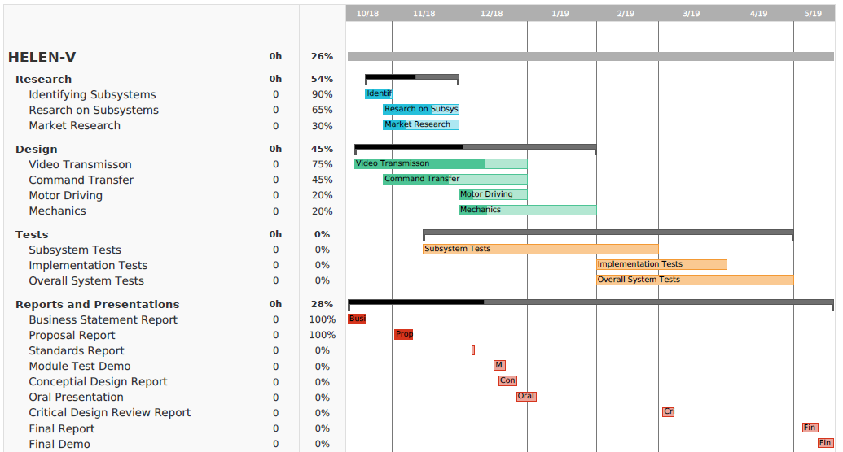

Figure 4: Gantt Chart of the company schedule